PROBLEM STATEMENT

|  |  |
| --- | --- |
| Date | 26 october 2023 |
| Team ID | NM2023TMID010005 |
| Project name | Food Tracking System |
| Marks | 2 marks |

PROBLEM STATEMENT:

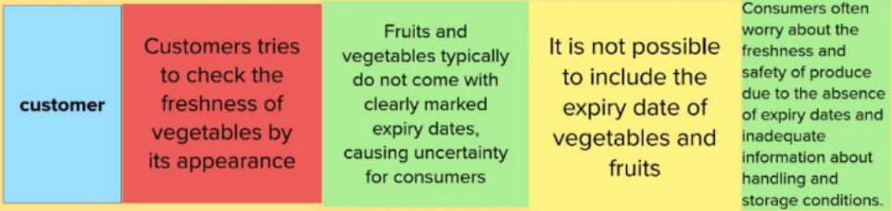

|  |  |  |  |  |  |
| --- | --- | --- | --- | --- | --- |
| **Problem statement** | **I am** | **I’m trying** | **But** | **Because** | **Which makes me feel** |
| **PS-1** | Customer | Customers tries to check the freshness of vegetables by its appearance | Fruits and vegetables typically do not come with clearly marked expiry dates, causing uncertainty for consumers | It is not possible to include the expiry date of vegetables and fruits | Consumers often worry about the freshness and safety of produce due to the absence of expiry dates and inadequate information about handling and storage conditions. |
| **PS-2** | Salesperson | Salesperson tries to sale the fruits and vegetables | Customers wants to check the freshness of fruits and vegetable. | Fruits and vegetables are not able to pack in preserved cover. | So it reduces the revenue and confidence in related to freshness. |